**WE Lab 1**

**Name: Muhammad Talha Usman**

**Roll No: 18-SE-70**

**Section: Omega**

**Submitted To: Ma’am Sidra Shafi**

**Task 1:**

**Code:**

<!DOCTYPE html>

<html lang="en">

<head>

    <meta charset="UTF-8">

    <meta name="viewport" content="width=device-width, initial-scale=1.0">

    <title>hotel site</title>

    <style type="text/css">

    .container{

        position:relative;

    }

    .container:hover{

        text-decoration:underline;

    }

    #topbar{

        width:100%;

        background-color: black;

        margin:0 auto;

        height:60px;

    }

    body{

        margin:0;

        padding:0;

    }

    .topbar-section{

        margin-left:50px;

        padding-right:45px;

        float:right;

        width:210px;

        border-right:2px white solid;

        height:100%;

     }

     .topbar-section-log{

        margin-left:50px;

        padding-right:45px;

        float:right;

        width:210px;

        height:100%;

     }

    #home{

        float:left;

        text-align: center;

        margin-right:30px;

    }

    #home-text{

        font-weight:bold;

        font-size:120%;

        position:relative;

        top:15px;

        color: white;

    }

    /* .aboutus-section{

        width:250px;

        border-right:2px blue solid;

        height:100%;

        } */

    /* #aboutus-text{

        font-weight:bold;

        font-size:120%;

        color:blue;

    } */

    .bg{

        background-position: 50% 50%;

        background-repeat: repeat;

        width:100%;

        height:100%;

    }

    #main-container{

        width:1000px;

        margin:0 auto;

    }

    </style>

</head>

<body>

    <div class="container">

        <div id="topbar">

            <div id="home" class="topbar-section">

                <span id="home-text"><a href="">HOME</a></span>

            </div>

            <div id="home" class="topbar-section">

                <span id="home-text"><a href="#about">ABOUT US</a></span>

            </div>

            <div id="home" class="topbar-section">

                <span id="home-text"><a href="#contact">Terms & Services</a></span>

            </div>

            <div id="home" class="topbar-section-log" id="log">

                <span id="home-text"><a href="login.html">LOG IN</a></span>

            </div>

        </div>

        <div><img class="bg" src="hotel-image.jpg"></div>

    </div>

    <div id="page-container">

        <div id="main-article">

            <h2 style="text-decoration:underline;margin-left:10px"><a name="about">ABOUT US</a></h2>

            <div style="margin-left:10px">

                Lorem Ipsum is simply dummy text of the printing and typesetting industry. Lorem Ipsum has been the industry's standard dummy text ever since the 1500s, when an unknown printer took a galley of type and scrambled it to make a type specimen book.

            </div>

            <h2 style="text-decoration:underline;margin-left:10px"><a name="contact">Term & Services</a></h2>

            <div style="margin-left:10px">

                Lorem Ipsum is simply dummy text of the printing and typesetting industry. Lorem Ipsum has been the industry's standard dummy text ever since the 1500s, when an unknown printer took a galley of type and scrambled it to make a type specimen book.

            </div>

        </div>

    </div>

</body>

</html>

**Login Page:**

<!DOCTYPE html>

<html>

<head>

    <title>Login Form</title>

    <style type="text/css">

      body

{

    margin: 0;

    padding: 0;

    background-color:black;

    font-family: 'Times New Roman';

}

.login{

        width: 382px;

        overflow: hidden;

        margin: auto;

        margin: 20 0 0 450px;

        padding: 80px;

        background: #23463f;

        border-radius: 15px ;

}

h2{

    text-align: center;

    color: #277582;

    padding: 20px;

}

label{

    color: #08ffd1;

    font-size: 17px;

}

#Uname{

    width: 300px;

    height: 30px;

    border: none;

    border-radius: 3px;

    padding-left: 8px;

}

#Pass{

    width: 300px;

    height: 30px;

    border: none;

    border-radius: 3px;

    padding-left: 8px;

}

#log{

    width: 300px;

    height: 30px;

    border: none;

    border-radius: 17px;

    padding-left: 7px;

    color: black;

    font-weight:bold;

}

span{

    color: white;

    font-size: 17px;

}

a{

    float: right;

    background-color: blue;

}

    </style>

</head>

<body>

    <h2>LOG IN</h2><br>

    <div class="login">

    <form id="login" method="get" action="login.php">

        <label><b>User Name

        </b>

        </label>

        <input type="text" name="Uname" id="Uname" placeholder="Username">

        <br><br>

        <label><b>Password

        </b>

        </label>

        <input type="Password" name="Pass" id="Pass" placeholder="Password">

        <br><br>

        <input type="button" name="log" id="log" value="Log In Here">

    </form>

</div>

</body>

</html>

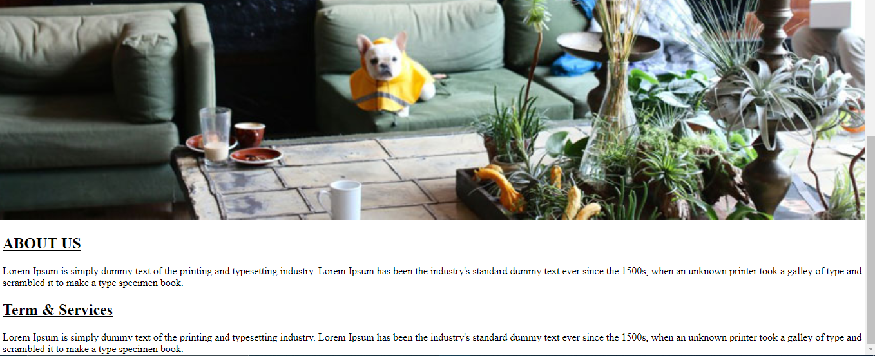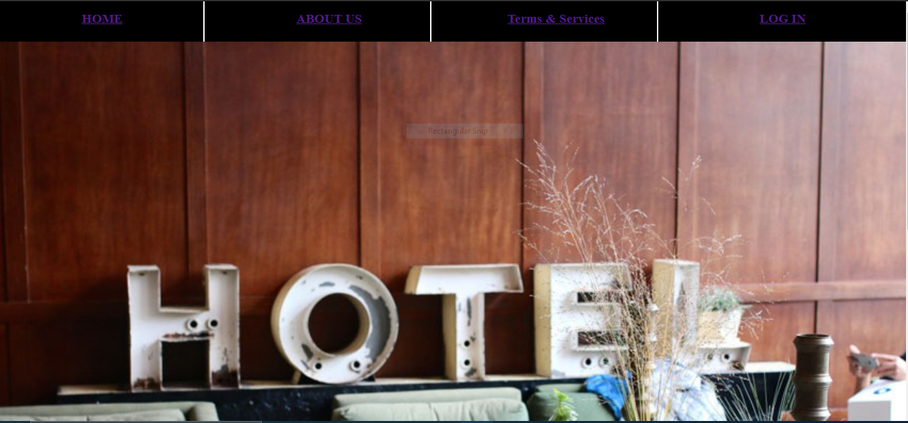**Output:**

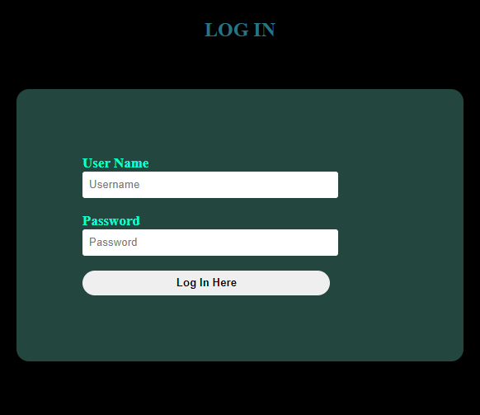

**Task 2:**

**Code:**

<!DOCTYPE html>

<html lang="en">

<head>

    <meta charset="UTF-8">

    <meta name="viewport" content="width=device-width, initial-scale=1.0">

    <title>Assignment</title>

</head>

<body>

    <form>

        <fieldset>

            <legend>create product</legend>

            Name:<br>

            <input type="text" name="Name" size=25><br><br>

            Price:<br>

            <input type="text" name="Price" size=25><br><br>

            Rank:<br>

            <input type="text" name="Rank" size=25><br><br>

            Category:<br>

            <select>

                <option value="Category"> Select Category</option>

                <option value="Dark">Dark</option>

                <option vaue="Negotiator">Negotiator</option>

                <option value="Sic mundus">Sic mundus</option>

            </select>

            <select>

                <option value="Sub Category">Sub Category</option>

                <option value="Jonas">Jonas</option>

                <option value=tong-wei">Tong-wei</option>

                <option value="Adam">Adam</option>

            </select>

            <br><br>

            Description<br>

            <textarea name="Description" cols="30" rows="10"></textarea>

            <br><br>

            Images<br><br>

            <input type="file" name="image">

            <input type="file" name="image">

            <input type="file" name="image">

            <br><br>

            <button type="submit">Create Product</button>

            <button type="reset">cancel</button>

        </fieldset>

    </form>

</body>

</html>

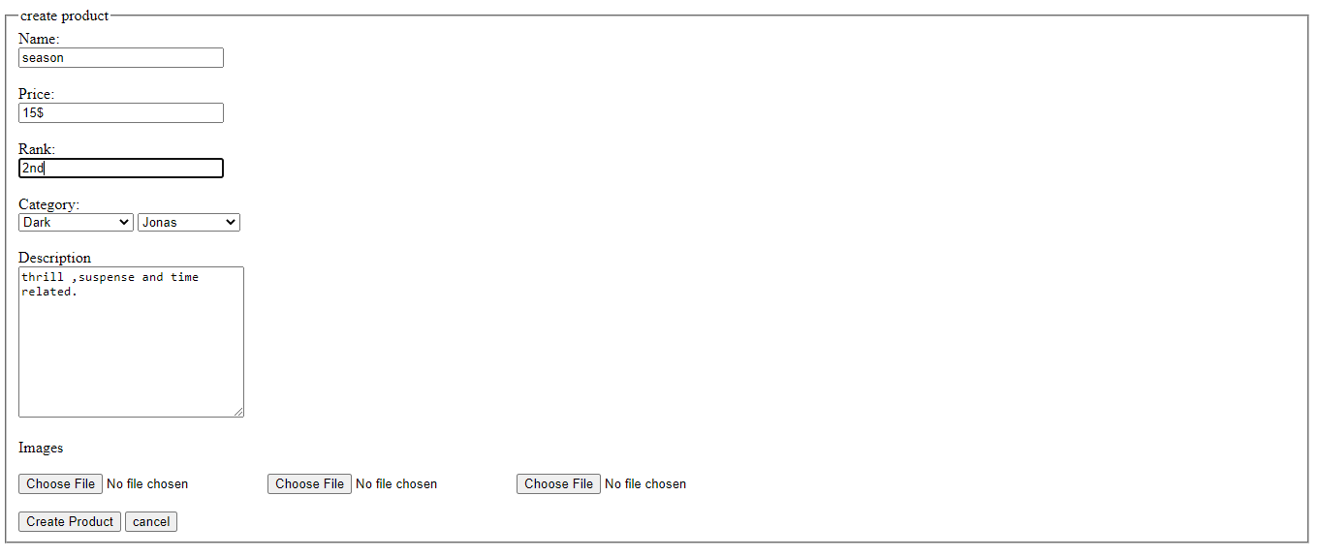**Output:**